# **MedAlertCare.com: Leading Medical Alert System in the USA**

A medical alert system is an essential device for ensuring the safety and well-being of seniors, particularly those living independently. These systems offer peace of mind by providing a quick and reliable way to reach help during an emergency. Whether it's a fall, sudden illness, or medical emergency, a medical alert system ensures that seniors can get assistance immediately, reducing the risks associated with living alone. With advancements in technology, these systems have become more user-friendly and versatile, offering features like fall detection, [GPS tracking](https://www.techtarget.com/whatis/definition/GPS-tracking), and 24/7 monitoring, making them indispensable for senior care.

Among the various options available, MedAlertCare stands out as the best medical alert system choice. With a focus on reliability, affordability, and ease of use, MedAlertCare provides seniors with the security they need, knowing help is just a button press away. Their innovative products, including medical alert pendants and GPS medical alert systems, are designed to cater to the unique needs of seniors, making MedAlertCare the top choice for families looking to enhance their loved ones’ safety.

## 

## **MedAlertCare.com Overview**

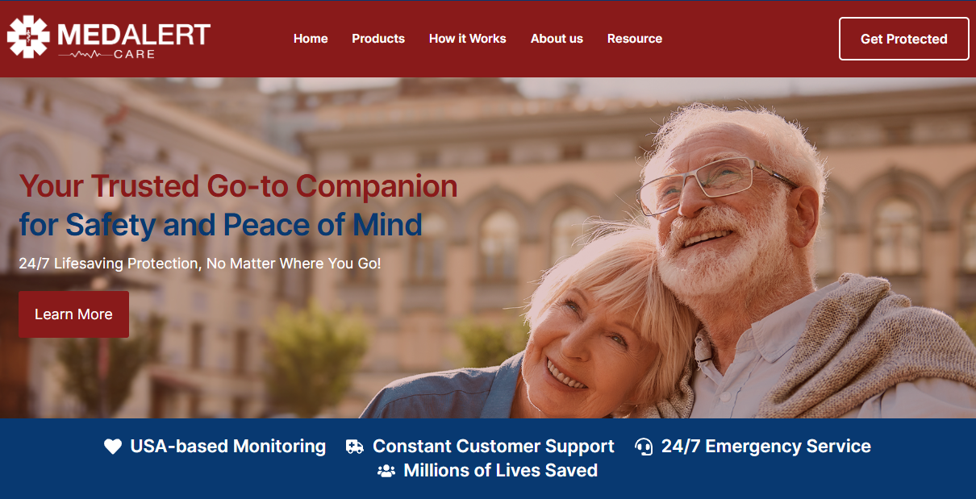

MedAlertCare.com is a trusted leader in providing innovative [medical alert devices for seniors](https://medalertcare.com/), offering a comprehensive range of products designed to give both seniors and their families peace of mind. With a commitment to quality and reliability, MedAlertCare ensures that seniors can live independently while staying connected to help in case of an emergency. Their user-friendly devices are designed to be worn daily, offering [reliable protection](https://medalertcare.com/blog/fall-detection-devices-a-reliable-protection-for-seniors/) without compromising comfort or ease of use.

MedAlertCare.com offers the range of medical alert system devices. These devices, including medical alert pendants, GPS-enabled systems, and medical alert watches, are tailored to meet the specific needs of seniors. Whether you're looking for fall detection, emergency alerts, or real-time location tracking, MedAlertCare.com provides reliable solutions that make safety easy and accessible for everyone.

## **MedAlertCare.com Medical Alert Devices**

## **Medical Alert Pendant**

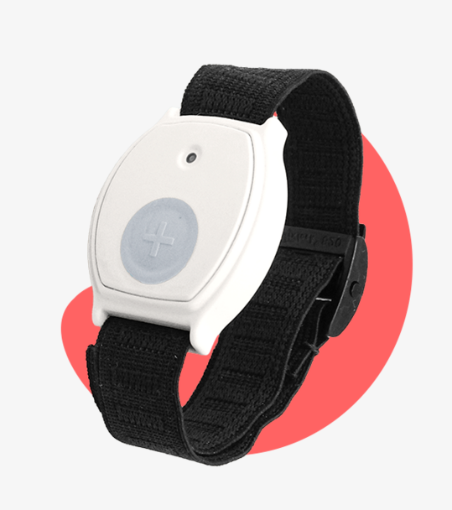

MedAlertCare.com's [medical alert pendant](https://medalertcare.com/products/medical-alert-pendant/) is a simple yet life-saving device that provides seniors with an immediate connection to help in case of an emergency. Designed to be worn around the neck, this discreet and easy-to-use pendant ensures that help is just a button press away. Whether it's a fall, sudden illness, or a medical emergency, the medical alert pendant alerts caregivers or emergency services instantly, offering peace of mind to both seniors and their families. Its lightweight design and simple functionality make it an ideal choice for those seeking reliable safety.

## **Medical Alert Watches**

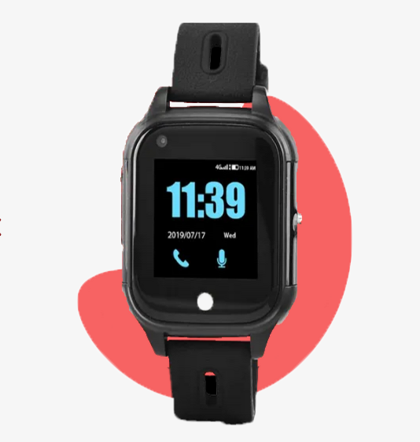

MedAlertCare.com offers [medical alert watch](https://medalertcare.com/products/medical-alert-watch/) that combine safety and style, offering seniors an advanced yet convenient solution for emergency situations. These wearable devices are designed with features like fall detection, emergency alerts, and health monitoring, all built into a comfortable, stylish watch. With a medical alert watch, seniors can feel secure knowing that help is available at the press of a button, no matter where they are. Whether it's tracking heart rate, monitoring steps, or alerting emergency services, medical alert watches offer a versatile, all-in-one safety solution for active seniors.

## **GPS Medical Alert Systems**

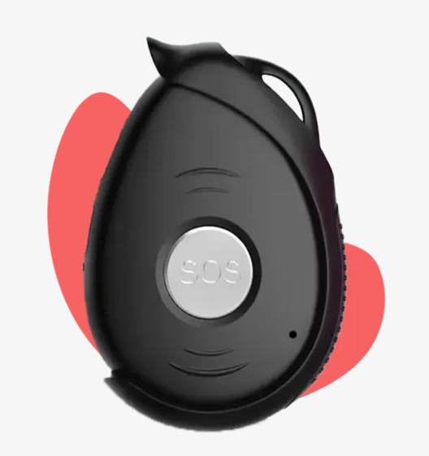

MedAlertCare.com's [GPS medical alert](https://medalertcare.com/products/gps-medical-alert/) is the perfect solution for seniors who want the freedom to roam while still being protected in case of an emergency. This [device uses GPS technology](https://medalertcare.com/blog/how-technology-keeps-seniors-connected-and-safe/) to track the wearer’s location in real-time, providing caregivers or family members with peace of mind. If a senior is lost, wandering, or experiencing a medical emergency, the GPS medical alert ensures that help is never far away. Whether at home or out and about, a GPS medical alert system ensures that seniors are always connected to their support network, providing safety wherever they go.

### 

## **Why Choose MedAlertCare.com?**

### **A Lifeline in Critical Moments**

When emergencies strike, seconds matter. MedAlertCare.com’s devices are designed for immediate response, ensuring seniors get the help they need without delay. Whether it’s a sudden fall or a medical emergency, the devices connect users to [caregivers](https://medalertcare.com/blog/wearable-medical-alert-devices-support-caregivers/) or emergency services in an instant. This lifesaving reliability is what sets MedAlertCare.com apart from the competition. These devices are built to handle the urgency of any situation, making them a must-have for seniors. With the touch of a button, seniors can feel empowered knowing that expert help is just moments away. This kind of rapid response could be the difference between a safe recovery and a serious injury, giving families peace of mind.

### **Simplicity Tailored for Seniors**

MedAlertCare.com prioritizes ease of use, knowing that seniors need straightforward solutions. Each product is thoughtfully designed with large, easy-to-press buttons, simple instructions, and user-friendly interfaces. Seniors can operate these devices confidently, without feeling overwhelmed by technology. This user-centric design makes the devices accessible to all, including those who may not be tech-savvy. MedAlertCare.com ensures that seniors don’t have to wrestle with complicated setups or confusing buttons. Instead, these devices are intuitive, providing comfort and familiarity that help seniors feel in control.

### **Versatile Options to Suit Every Lifestyle**

No two seniors are the same, and MedAlertCare.com recognizes this by offering a variety of devices. From lightweight pendants to stylish watches and GPS-enabled systems, there’s a product for every preference. These options empower seniors to choose devices that seamlessly fit into their daily lives. Whether they prefer something discreet or fashionable, MedAlertCare.com ensures that safety doesn’t have to come at the cost of style. The range of options also allows seniors to select a device based on their lifestyle, whether they’re homebodies or active explorers. This level of personalization helps make safety a natural part of their routine.

## **How MedAlertCare.com Enhances Senior Independence**

### **1. Empowering Seniors with Confidence**

MedAlertCare.com’s devices give seniors the confidence to live independently, knowing help is always within reach. Whether it’s a medical pendant necklace or a fall detection watch for seniors, these device provide a sense of security that allows seniors to stay active and engaged in their daily lives. This sense of independence boosts their mental and emotional well-being, as they no longer need to worry about being isolated during an emergency. By removing the fear of being alone, MedAlertCare.com fosters a more fulfilling and active lifestyle for seniors.

### **2. Supporting Families with Peace of Mind**

For families, MedAlertCare.com provides reassurance that their loved ones are safe. Devices like monitoring devices for seniors and GPS-enabled systems allow caregivers to stay informed about their loved ones’ well-being, even from a distance. This strengthens the connection between seniors and their families, helping both parties feel more at ease. Families can track real-time locations, receive emergency alerts, and ensure their loved ones are safe wherever they go, making them feel connected and in control no matter the distance.

### **3. Bridging Technology and Simplicity**

While many safety devices can be overwhelming, MedAlertCare.com keeps things simple. Their products are thoughtfully designed to make advanced technology accessible to seniors, ensuring usability without sacrificing functionality. This approach eliminates unnecessary complexity, allowing seniors to quickly grasp how the devices work. By focusing on simplicity, MedAlertCare.com ensures that seniors feel empowered, rather than frustrated, by technology, making it a seamless addition to their lives.

## **Why MedAlertCare.com Is the Leader in Medical Alert Systems**

MedAlertCare.com goes beyond selling devices—it builds trust with its customers. Families and seniors choose MedAlertCare.com for its commitment to quality, innovation, and reliability. Their strong reputation is built on the consistent performance of their products, and the company’s genuine desire to improve the lives of seniors. This trust is further reinforced by their transparency, clear communication, and unwavering support for their customers throughout their journey.

### **Unmatched Reliability**

Every device is rigorously tested to ensure it works perfectly in emergencies. MedAlertCare.com understands that the reliability of their devices can be a matter of life or death, which is why they prioritize quality control and continuous improvement. They go the extra mile to ensure their products perform under the most stressful situations, so seniors and their families can always rely on them when needed the most.

#### 

### **Exceptional Support**

The company provides outstanding customer service, helping seniors and their families with everything from setup to troubleshooting. Their team is available around the clock, ensuring that assistance is always just a phone call away. This exceptional support extends beyond purchasing the product; MedAlertCare.com’s customer service ensures that families have the guidance they need to use their devices effectively and without any stress.

### 

### **Final Verdict**

MedAlertCare.com is changing the way seniors and their families think about safety. With innovative products like the medical alert pendant, medical alert watches, and GPS-enabled systems, they provide reliable, user-friendly solutions that empower seniors to live confidently and independently. These products aren’t just device—they are peace of mind, offering both seniors and their families a sense of security that transcends physical devices.

Whether you’re seeking a medical pendant alarm, a fall detection watch for seniors, or a GPS tracker for elderly, MedAlertCare.com has the perfect device to meet your needs. Their range of products ensures that no matter what a senior’s lifestyle or safety needs may be, there is a MedAlertCare.com solution that fits. Visit [MedAlertCare.com](https://medalertcare.com/) today to explore their range of products and take the first step toward peace of mind for you and your loved ones. Their commitment to quality and customer satisfaction makes them the ideal partner in keeping seniors safe, independent, and happy.

### **FAQ's**

**What makes MedAlertCare.com the best choice for medical alert systems for seniors?**

MedAlertCare.com stands out due to its focus on reliability, affordability, and user-friendly designs. Their products, including medical alert pendants, watches, and GPS systems, are tailored to meet the unique needs of seniors, ensuring quick access to help in emergencies. The devices are simple to use, featuring large buttons and intuitive interfaces, making them accessible to seniors with varying levels of tech experience. With 24/7 monitoring and real-time tracking, MedAlertCare.com offers peace of mind for both seniors and their families.

**How does MedAlertCare.com GPS medical alert system work?**

MedAlertCare.com’s GPS medical alert system uses real-time tracking technology to monitor the wearer’s location, providing caregivers and family members with peace of mind. If a senior experiences a medical emergency or gets lost, the GPS-enabled device ensures that help can quickly be dispatched to their exact location. This system is ideal for seniors who want the freedom to roam while maintaining safety, whether at home or out and about. It offers a seamless connection to emergency services, ensuring that seniors are always connected to help.

**Are MedAlertCare.com devices easy to use for seniors?**

Yes, MedAlertCare.com prioritizes ease of use in all of their products. Devices like medical alert pendants and watches feature large, easy-to-press buttons and simple instructions that make them accessible for seniors, even those who are not tech-savvy. The user-friendly design ensures that seniors can operate these devices with confidence, without feeling overwhelmed by complex technology. MedAlertCare.com’s commitment to simplicity makes their devices intuitive and comfortable to use for all seniors.

**What kind of customer support does MedAlertCare.com offer?**

MedAlertCare.com offers exceptional customer support, ensuring that seniors and their families have access to assistance whenever needed. Their customer service team is available around the clock to help with setup, troubleshooting, and any questions about using their devices. This comprehensive support helps users feel confident in their ability to operate their medical alert systems and resolve any issues quickly. The company’s commitment to outstanding customer service ensures peace of mind throughout the ownership of their products.

**Other Useful Resources**

[Medical Alert Devices for Seniors | Features & Benefits](https://ekonty.com/blogs/73022/Medical-Alert-Devices-for-Seniors-Features-Benefits)

[How GPS Medical Alert Provide Freedom and Security for Seniors](https://www.myvipon.com/post/1433494/How-GPS-Medical-Alert-Provide-Freedom-amazon-coupons.)

[Stay Safe Anywhere: The Ultimate Medical Alert Systems for 2025](https://hackmd.io/@1ziteRqyQfaBs22w2w04jg/stay-safe-anywhere-the-ultimate-medical-alert-systems-for-2025)