# TheGoodAI.com: A Disappointing Tool for AI Solutions

In the rapidly evolving world of artificial intelligence, finding reliable and effective tools is crucial. Unfortunately, my experience with TheGoodAI.com has been far from satisfactory. Despite its promising name and seemingly impressive features, this platform has proven to be a major disappointment. In this detailed review, I’ll explain why TheGoodAI.com feels like a scam and a bad deal, covering various aspects of the tool that failed to meet expectations.

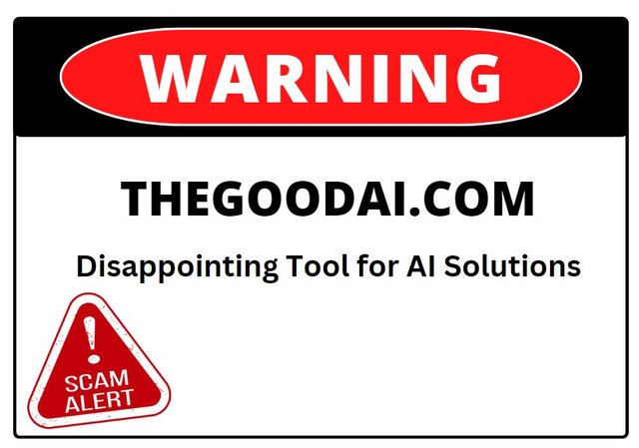

### ****Introduction to TheGoodAI.com****

TheGoodAI.com presents itself as a cutting-edge solution for AI needs, boasting a range of features that seem designed to appeal to a broad audience. From machine learning algorithms to data analytics, the platform promises to deliver advanced AI capabilities. However, my exploration of TheGoodAI.com has revealed several issues that make it appear to be a misleading and potentially fraudulent service.

### ****Overhyped Claims: A Phony Promise?****

When I first encountered TheGoodAI.com, the site made bold claims about its capabilities. It advertised itself as a comprehensive AI tool that could handle everything from data analysis to predictive modeling. The marketing materials suggested that it was a revolutionary platform, offering unparalleled features and performance.

However, these claims turned out to be nothing more than a trick. The tool did not deliver on its promises. The features that were highlighted as groundbreaking were, in reality, either nonexistent or underwhelming. This discrepancy between the advertised capabilities and the actual performance of TheGoodAI.com made me question whether it was simply a phony product designed to attract users with false hopes.

### ****Misleading Features: A Fraud of AI Solutions****

One of the major disappointments with TheGoodAI.com was its list of features. The platform touted a range of AI tools, including advanced analytics, machine learning models, and data visualization capabilities. However, my experience showed that these features were either fake or grossly underdeveloped.

For instance, the so-called advanced analytics tools turned out to be basic and ineffective. Instead of offering insightful analysis, they provided vague and misleading results. The machine learning models were similarly lackluster, with limited customization options and poor performance. This sham of features was a clear indicator that TheGoodAI.com was not the real deal but rather a bad deal for anyone seeking genuine AI solutions.

### ****Performance Issues: A Bogus Experience****

The performance of TheGoodAI.com was another significant letdown. Despite the high expectations set by its marketing, the platform frequently exhibited poor performance. Slow processing times, frequent crashes, and unresponsive features were common issues that plagued my experience.

This unreliable performance felt like a con, as the tool failed to live up to its promises. The supposed advanced algorithms and efficient processing were nowhere to be found, leaving me with a product that seemed more like a rip-off than a legitimate AI solution. For users who rely on AI tools for critical tasks, this kind of performance is not only disappointing but also unacceptable.

### ****User Interface: A Trick to Conceal Flaws****

TheGoodAI.com’s user interface also contributed to the overall sense of disappointment. The platform was designed to look sleek and modern, but this superficial appearance masked deeper issues. The interface was confusing and difficult to navigate, which made it challenging to use the tool effectively.

This confusing design felt like a trick to distract users from the platform’s shortcomings. Instead of focusing on user experience and functionality, TheGoodAI.com seemed to prioritize style over substance. This approach not only made the tool frustrating to use but also highlighted the fact that the platform was not genuinely invested in delivering a quality AI solution.

### ****Customer Support: A Scam Service****

Another area where TheGoodAI.com fell short was in customer support. Despite encountering numerous issues with the tool, I found the support team to be unresponsive and unhelpful. My attempts to reach out for assistance were met with generic replies and little to no resolution of my problems.

This lack of effective customer support added to the sense that TheGoodAI.com was a sham. If a company cannot provide adequate support for its product, it further suggests that the tool is not genuinely committed to serving its users. For anyone relying on this platform, the absence of reliable support is a significant red flag and reinforces the feeling that the tool is a fraud.

### ****Pricing: A Bad Deal****

The pricing structure of TheGoodAI.com was another aspect that felt misleading. The platform offered various subscription plans, each promising additional features and capabilities. However, the value provided did not justify the cost.

In my experience, the subscription plans felt like a bad deal. The features that were promised as part of higher-tier plans were often either nonexistent or of little use. This pricing strategy seemed designed to extract as much money as possible from users while delivering minimal value in return. This pricing model further reinforced the notion that TheGoodAI.com might be a scam or a rip-off.

### ****Security and Privacy Concerns: A Potential Fraud****

Security and privacy are critical considerations when dealing with AI tools, especially those that handle sensitive data. Unfortunately, TheGoodAI.com did not provide sufficient reassurance regarding its security measures. The lack of transparency about how user data was handled and protected raised significant concerns.

This lack of clear information about data security and privacy made me question whether TheGoodAI.com could be trusted with confidential information. The absence of robust security measures suggested that the platform might be engaging in fraudulent practices, potentially putting user data at risk. This aspect of the tool added to the overall sense of it being a dishonest or phony service.

### ****Reviews and Feedback: A Conspiracy of Discontent****

Looking at reviews and user feedback about TheGoodAI.com revealed a pattern of dissatisfaction. Many users shared similar experiences of poor performance, misleading features, and unresponsive customer support. This widespread discontent further supported the idea that [TheGoodAI.com is not a trustworthy tool](https://www.the-good-ai.com/).

The consistency of negative feedback from various sources suggested that the platform’s issues were not isolated but rather indicative of a larger problem. This collective discontent reinforced the belief that TheGoodAI.com might be a con, designed to lure users with deceptive claims and then deliver a subpar experience.

### ****Conclusion: Avoiding TheGoodAI.com****

In conclusion, TheGoodAI.com has proven to be a deeply disappointing tool for AI solutions. From its overhyped claims and misleading features to its poor performance and inadequate customer support, there are numerous reasons to be skeptical of its legitimacy. The tool’s high pricing, questionable security practices, and consistent negative feedback further suggest that it could be a scam or a rip-off.

For anyone seeking reliable and effective AI solutions, it is crucial to look beyond the promises made by platforms like TheGoodAI.com. It’s important to thoroughly research and evaluate tools to ensure that you’re investing in a genuine and trustworthy product. Based on my experience, I would strongly recommend avoiding TheGoodAI.com and exploring other options that offer real value and dependable performance.