# **Types of Papers PerfectEssayWriter.ai Essay Grader Handles**

In the world of academic and professional writing, the ability to produce high-quality, error-free documents is crucial. Whether you're a student working on essays and research papers or a teacher grading a multitude of assignments, the quality of writing plays a significant role in academic success and professional effectiveness. PerfectEssayWriter.ai offers a powerful solution to these challenges with its essay grader, a tool designed to enhance the writing process for a wide range of paper types.

This article explores how PerfectEssayWriter.ai [essay grader](https://perfectessaywriterai.gitbook.io/aitools/perfectessaywriter.ai-essay-grader) can assist in various writing tasks, its features, benefits for both students and teachers and how it works to improve paper quality.

## **PerfectEssayWriter.ai Overview**

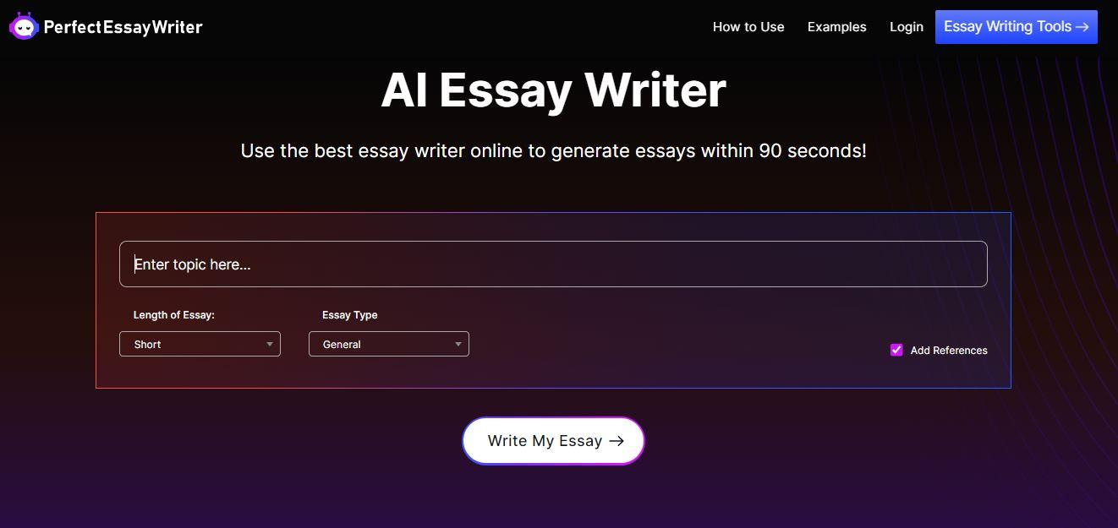

PerfectEssayWriter.ai is an [AI writing tool](https://www.perfectessaywriter.ai/) designed to meet the needs of students and educators. It offers a comprehensive [suite of tools](https://perfectessaywriterai.gitbook.io/aitools) designed to aid in writing, revising, and grade documents. Among its standout features is the AI Essay grader, which provides instant and thorough feedback on a wide variety of documents. This tool is not just a grammar checker; it assesses the quality of writing, structure, and adherence to assignment requirements, making it a valuable asset for anyone involved in academic or professional writing.

*Students appreciate PerfectEssayWriter.ai for its extensive range of writing tools, which provide comprehensive academic support. This essay writer is one of the best AI writing tools available on the market.* [*Best AI Tools and Essay Writing Services for Students in 2024*](https://orah.co/best-ai-tools-and-essay-writing-services-for-students-in-2024/)***Orah.co Reviews on PerfectEssayWriter.ai***

## **PerfectEssayWriter.ai AI Essay Grader**

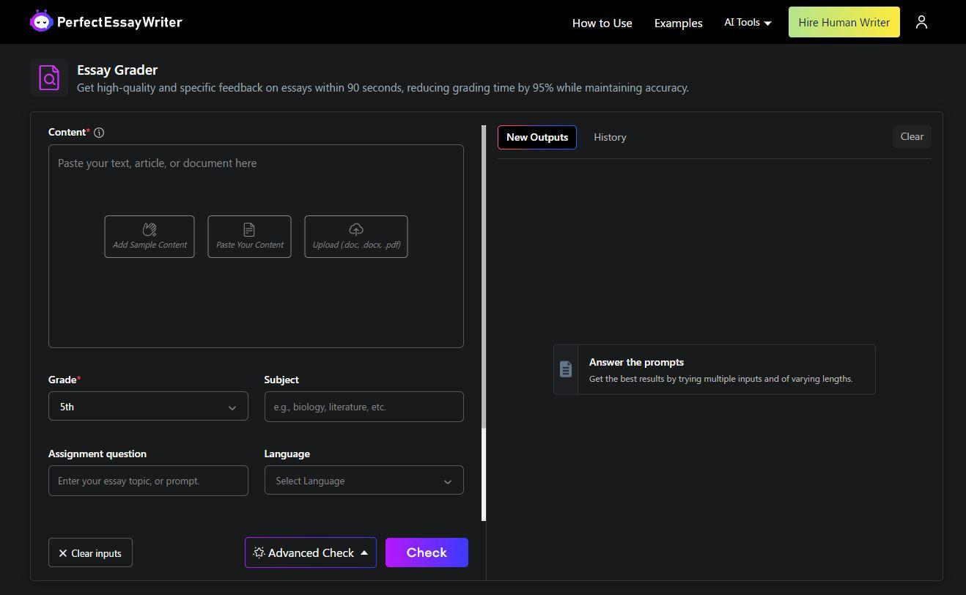

PerfectEssayWriter.ai offers an essay grader that uses artificial intelligence to deliver real-time feedback on written documents. This tool is designed to evaluate various aspects of writing, including grammar, punctuation, style, and structure. It offers detailed suggestions for improvement, helping users enhance the clarity and effectiveness of their writing. The [essay grader online](https://www.perfectessaywriter.ai/essay-grader) is particularly useful for detecting common writing errors, such as awkward phrasing and sentence structure issues, and for ensuring that documents adhere to specific grading rubrics.

## **Types of Papers PerfectEssayWriter.ai Essay Grader Online Can Assess**

PerfectEssayWriter.ai’s AI Essay grader is designed to handle a diverse range of document types. Whether you're working on a standard essay or a complex research paper, the tool adapts to provide the necessary feedback for improvement. Here’s a detailed look at the types of papers the AI Essay grader can assess:

### **Essays**

* **Argumentative Papers:** These essays present arguments and counterarguments on a specific topic. The AI Essay grader helps ensure that arguments are logically structured and supported with evidence.
* **Expository Essays:** These essays explain or inform about a particular subject. The tool checks for clarity and coherence in presenting information.
* **Narrative Compositions:** These essays tell a story or recount an experience. The AI Essay grader evaluates narrative flow and engagement.
* **Descriptive Essays:** These essays provide detailed descriptions of people, places, or objects. The tool assesses the effectiveness of descriptive language and imagery.

### **Academic Papers**

* **Research Papers:** These documents involve extensive research and analysis. The AI Essay grader helps verify the accuracy of information and the coherence of arguments.
* These are detailed academic documents that present original research. The tool checks for proper formatting, structure, and adherence to academic standards.
* **Dissertations:** These extensive works require rigorous analysis and documentation. The AI Essay grader ensures that dissertations meet high academic standards and maintain a logical flow.

### **Coursework Assignments**

* **Lab Reports:** These documents summarize experiments and results. The AI Essay grader helps in organizing findings and ensuring clarity.
* **Case Studies:** These analyze specific instances or problems. The tool checks for thorough analysis and clear presentation of case details.
* **Literature Reviews:** These reviews analyze existing research on a topic. The AI Essay grader evaluates the comprehensiveness and organization of the review.

### **Professional Documents**

* **Presentations:** These documents support oral presentations. The AI Essay grader ensures that presentations are clear and effectively convey key points.
* **Articles:** These written pieces for publication require clarity and precision. The tool helps in refining language and structure for a professional audience.

## **Key Functions of the AI Essay grader**

* **Instant Feedback:** Provides real-time corrections and suggestions for improvements.
* **Error Detection:** Identifies and highlights grammar mistakes, punctuation errors, and awkward phrasing.
* **Rubric Adherence:** Allows users to input custom grading rubrics to align feedback with specific assignment criteria.
* **Plagiarism Detection:** Checks for originality to ensure that content is not copied.
* **Comprehensive Analysis:** Evaluates the overall structure, coherence, and clarity of the document.

## **Key Features of PerfectEssayWriter.ai Essay Grader**

PerfectEssayWriter.ai’s AI Essay grader stands out due to its comprehensive set of features designed to enhance the quality of written documents. Here’s a closer look at some of its key features:

* **Real-time Feedback:** The tool provides immediate corrections and suggestions, allowing users to make instant improvements to their writing. This feature is particularly useful for revising drafts quickly and efficiently.
* **Error Highlighting:** Common writing errors, such as grammatical mistakes, punctuation errors, and awkward phrasing, are highlighted for easy identification. This helps users address issues promptly and improve overall writing quality.
* **Adherence to Grading Rubrics:** Users can input specific grading rubrics, and the AI Essay grader evaluates the document based on these criteria. This ensures that feedback aligns with assignment expectations and helps in achieving grading consistency.
* **Plagiarism Detection:** The tool includes a plagiarism detection feature that checks for originality and ensures that the content is not copied from other sources. This is crucial for maintaining academic integrity.
* **Comprehensive Analysis:** Beyond error detection, the AI Essay grader evaluates the overall structure, coherence, and clarity of the document. It provides feedback on logical flow and effectiveness, helping users produce well-rounded and polished papers.

## **Benefits for Students and Teachers**

The AI Essay grader by PerfectEssayWriter.ai offers numerous benefits for both students and teachers, making it a valuable tool in the academic environment.

### **For Students**

* **Improved Writing Skills:** The tool helps students identify and correct common writing errors, enhancing their overall writing skills.
* **Guidance for Revisions:** Instant feedback allows students to make revisions before submitting their work, leading to higher-quality final drafts.
* **Easy Access to Feedback:** Students receive detailed feedback quickly, helping them understand areas for improvement and make necessary changes.

### **For Teachers**

* **Time-Saving:** The AI Essay grader automates much of the grading process, saving teachers valuable time and allowing them to focus on other aspects of teaching.
* **Consistent Feedback:** By providing objective and consistent feedback, the tool helps teachers maintain grading fairness and accuracy.
* **Customized Grading:** Teachers can input specific grading rubrics, ensuring that the feedback aligns with assignment requirements and expectations.

## **How PerfectEssayWriter.ai AI Essay Grader Works**

The AI Essay grader operates through a straightforward process that simplifies the writing and grading workflow. Here’s a step-by-step overview of how it works:

* **Upload the Document:** Users start by uploading their document into the AI Essay grader platform. This can be any type of writing, from essays to research papers.
* **Select Document Type and Rubric:** Users choose the type of paper they are working on and input any specific grading rubrics if needed. This helps the tool tailor its feedback according to the document’s requirements.
* **AI Scanning and Analysis:** The tool scans the document for various writing elements, including grammar, punctuation, and structural issues. It also checks for adherence to custom rubrics and originality.
* **Receive Instant Feedback:** Users receive a detailed report with corrections and suggestions for improvement. The feedback highlights errors and provides recommendations for enhancing the document.
* **Revise and Resubmit:** Users can make revisions based on the feedback provided and resubmit the document for further evaluation if needed. This iterative process helps in refining the writing.

PerfectEssayWriter.ai essay grader is a powerful tool designed to [help students](https://cgscholar.com/community/community_profiles/community-47726/community_updates/190753) in their writing. This tool offers instant, comprehensive feedback on a variety of paper types, enabling students to refine their skills effectively. By adhering to detailed grading rubrics and checking for plagiarism, PerfectEssayWriter.ai essay grader ensures that students produce polished, high-quality documents. It also assists teachers by streamlining the grading workflow, making the [process more efficient and less time-consuming](https://latinosdelmundo.com/article/ai-essay-grader-accurate-fast-and-effective-evaluation+). With its ability to detect errors and provide actionable insights, the AI Essay Grader is essential for both enhancing writing quality and simplifying grading tasks.

Moreover, for those who prefer to access these features on the go, PerfectEssayWriter.ai is also available in the [AI essay writer app](https://www.perfectessaywriter.ai/app). This app brings the same advanced functionalities to mobile devices, allowing users to edit and check their documents anytime, anywhere. With the AI essay writer app, users can enjoy the convenience of real-time feedback and document assessment at their fingertips, making it easier than ever to maintain writing excellence.

### **FAQs**

**How accurate is the AI in detecting nuanced writing errors?**

The AI Essay grader uses advanced algorithms to analyze writing, including nuanced errors like subtle stylistic issues and complex sentence structures. While it provides highly accurate feedback, it’s still advisable for users to review suggestions and apply their judgment to ensure the highest quality of writing.

**Is there a limit to the length of documents that can be checked?**

The AI Essay grader can handle a range of document lengths, from short essays to long research papers. However, very large documents might experience longer processing times. For extremely lengthy documents, consider breaking them into sections for a more efficient review process.

**How does the AI Essay grader integrate with other writing tools or platforms?**

PerfectEssayWriter.ai’s AI Essay grader can often be integrated with other writing tools and platforms through file uploads or copy-pasting text. For seamless integration, users should check for specific compatibility options or plugins available for their preferred writing software.

**Other Useful Resources**

[Transform Your Writing with AI-Powered Essay Grading](https://repurtech.com/transform-your-writing-with-ai-powered-essay-grading/)

[Make the Grade: How an Essay Grader Can Help You](https://www.storeboard.com/blogs/education/make-the-grade-how-an-essay-grader-can-help-you-succ/5853775)

[How PerfectEssayWriter.ai’s Essay Grader Helps You Excel](https://www.zupyak.com/p/4265634/t/how-perfectessaywriter-ais-essay-grader-helps-you-excel)