All About Hastelloy Washers

Hastelloy is an alloy of nickel, molybdenum, and chromium, with significant amounts of tungsten, cobalt, and iron. The high-performance alloy is known for its superior corrosion and heat resistance properties under harsh and aggressive industrial environments. Hastelloy washers are an essential component of many industrial applications.

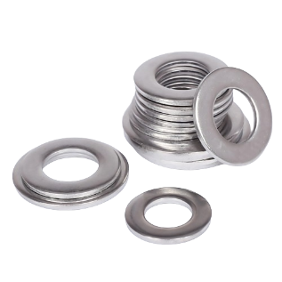

Properties of Hastelloy Washers

Hastelloy is a family of alloys with varying properties such as corrosion resistance, strength, and durability. Hastelloy C-276 is the most common variety that provides exceptional corrosion and heat resistance in severe environments.

Other varieties include Hastelloy B-2, Hastelloy X, and Hastelloy W, which provide specific properties such as high temperature and chemical resistance. Hastelloy Washers from these alloys exhibit excellent mechanical strength and resistance to stress corrosion and pitting, making them ideal for demanding applications where corrosion resistance is necessary.

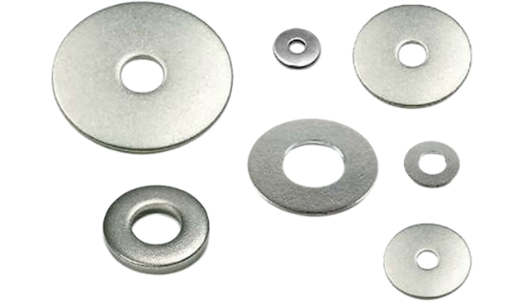

Advantages of Hastelloy Washers

Hastelloy washers offer several advantages over other materials, such as stainless steel and titanium. They are highly corrosion and heat-resistant, making them suitable for harsh and severe environments. Hastelloy washers can withstand exposure to corrosive acids, alkaline solutions, and reducing and oxidizing atmospheres. Furthermore, they exhibit excellent strength, flexibility, and toughness, making them suitable for high-stress applications.

Applications of Hastelloy Washers

Hastelloy washers are used in various applications where corrosion and high-temperature resistance are critical. Some of the common applications include chemical processing plants, oil refineries, power generation, and aerospace industries. They are used in constructing heat exchangers, reactors, and valves where severe corrosion and high temperatures are encountered. Furthermore, Hastelloy washers are used in marine applications because of their excellent resistance to saltwater corrosion.

Manufacturing Process

Hastelloy washers are manufactured using standard production processes such as cold heading, stamping, and machining. The manufacturing process involves the selection of the appropriate Hastelloy alloy, followed by shaping, heat treatment, and finishing. Depending on the application requirements, hastelloy washers are available in various sizes, shapes, and thicknesses.

Maintenance

Hastelloy washers require less maintenance than other materials because of their superior corrosion and heat resistance properties. They can easily withstand exposure to harsh chemicals and extreme temperatures without significant damage or degradation. Regular inspection and cleaning are necessary to prevent any damage from exposure to corrosive environments.

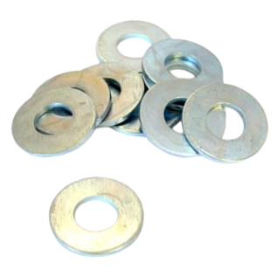

Conclusion

Hastelloy washers are essential to many industrial applications requiring superior corrosion and heat resistance properties. Their excellent mechanical strength, flexibility, and toughness suit high-stress applications in harsh environments. They are used in various industries, such as chemical processing, oil refining, power generation, and aerospace. Hastelloy washers are manufactured using standard production processes and are available in various sizes and shapes. They require minimal maintenance and long service life, making them a cost-effective solution for many applications.

