# **Top 5 AI Essay Helpers for Better Writing in 2024**

In today’s era, AI tools are a booming in essay writing. These tools are like having a helpful assistant that makes writing easier and faster. They can guide you through the entire process, from brainstorming ideas to polishing your final draft.

AI tools help in several ways. They can check your work for spelling and grammar mistakes, suggest improvements, and make sure your writing flows smoothly. They also help you organize your thoughts and structure your essay in a clear and logical way.

By using these AI tools, you can write better essays more quickly. They save you time by catching errors you might miss and offer suggestions to improve your work. As a result, you end up with well-written essays that are clear and effective.

## **Best AI Tools For Human Better Writing**

1. PerfectEssayWriter.ai

2. MyEssayWriter.ai

3. WritesonicAI

4. CopyAI

5. JasperAI

### 

# **1. PerfectEssayWriter.ai**

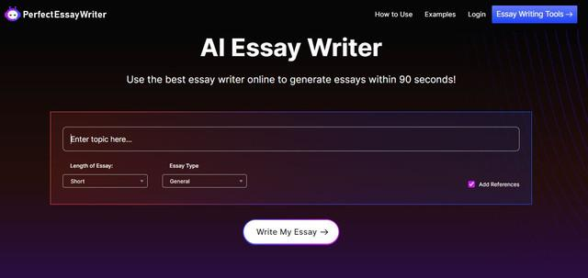

PerfectEssayWriter.ai stands out as a comprehensive [essay writer](https://www.perfectessaywriter.ai/) assistant, offering a suite of tools designed to improve various aspects of the writing process. Whether you're a student, researcher, or professional, this platform provides essential features to ensure your writing is polished and accurate.

## **Endorsed by Re-thinkingthefuture:**

PerfectEssayWriter.ai is a versatile AI Essay Writer that can support over 20 languages, including Dutch, Swedish, Italian, and more. Not only that, but it always generates original and plagiarism-free content. Whether you’re writing a research paper or analyzing literature, PerfectEssayWriter.ai gives you the tools to write, improve, and get ideas for your paper. [Re-thinkingthefuture](https://www.re-thinkingthefuture.com/technologies/gp1858-best-ai-essay-writing-tools-for-students-2024/#:~:text=PerfectEssayWriter.ai%20is,for%20your%20paper.)

## **Key Features**

* **Paraphrasing Tool**: [Paraphrasing tool](https://www.perfectessaywriter.ai/paraphrasing-tool) helps in rewriting sentences and paragraphs to enhance clarity and originality. It maintains the meaning of the text while presenting it in a new way, which is invaluable for avoiding redundancy and improving readability.
* **Plagiarism Checker**: PerfectEssayWriter.ai’s [plagiarism checker](https://www.perfectessaywriter.ai/plagiarism-checker) scans your text for any potential overlaps with existing sources. It helps ensure that your work is original and properly cited, which is crucial for academic integrity.
* **Citation Generator**: [Citation Generator](https://www.perfectessaywriter.ai/citation-machine) automatically generates citations in various formats (APA, MLA, Chicago, etc.), saving time and reducing errors when referencing sources.
* **AI Content Detector**: [AI content detector](https://www.perfectessaywriter.ai/ai-detector) ensure that your text is authentic and written in your unique voice. This feature is especially useful for maintaining originality in academic and professional writing.
* **AI Summarizer**: The [AI summarizer](https://www.perfectessaywriter.ai/summarizer) condenses lengthy documents into concise summaries, making it easier to grasp the key points without reading through extensive text.
* **AI Humanizer**: [AI humanizer](https://www.perfectessaywriter.ai/content-humanizer) enhances the natural flow and readability of the text, making it sound more human-like and engaging. This tool adjusts the tone and style to better resonate with your audience.

### **Best For**

PerfectEssayWriter.ai is a perfect solution for people who are looking for a complete place to write essays in order to simplify and improve their work. It provides a complete suite of features designed to support multiple aspects of the writing system, including a thorough plagiarism check to guarantee originality, efficient citation management to ensure correct referencing, and high-tech content enhancement tools to enhance clarity, coherence, and overall quality. PerfectEssayWriter.ai provides users with a powerful solution for producing high quality, well-structured, and authentic written content, which makes it an important resource for students, scientists, and professionals.

# **2. MyEssayWriter.ai**

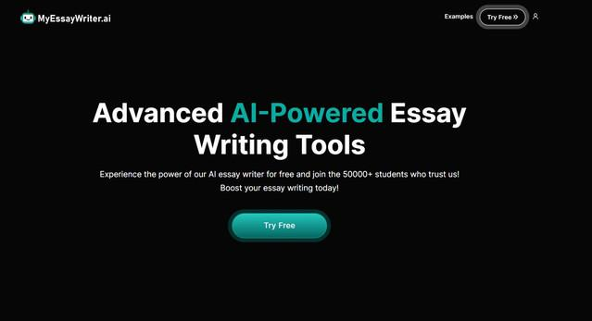

MyEssayWriter.ai [AI essay writer](https://www.myessaywriter.ai/) is best for students and writers looking for reliable writing assistance. It offers tools specifically designed to help with essay writing, topic generation, and plagiarism checking.

## **Key Features**

* **AI Letter Generator:** The [AI Letter Generator](https://www.myessaywriter.ai/ai-letter-generator) in MyEssayWriter.ai streamlines the creation of professional and personalized letters with its intuitive templates and smart suggestions. It ensures your correspondence is well-structured and effectively conveys your message.
* **Essay Topic Generator**: The [essay topic generator](https://www.myessaywriter.ai/essay-topic-generator) provides creative and relevant topic suggestions based on your input, helping to kickstart the writing process and overcome writer's block.
* **Paragraph Generator:** The [Paragraph Generator](https://www.myessaywriter.ai/paragraph-generator) in MyEssayWriter.ai helps users effortlessly craft detailed and coherent paragraphs by expanding on brief prompts. It simplifies content development, enhancing the clarity and organization of your writing.

### **Best For**

For students looking for reliable help in addition to their academic writing, MyEssayWriter.ai is a great choice, especially in the creation of the topic and the protection of the originality of its function. The platform provides simple and user-friendly tools designed to simplify the authoring system, making it easier for students to choose the appropriate essay topic and carry out a thorough plagiarism check. MyEssayWriter.ai, with its simple interface and focused functions, assists students in producing a well-researched and original college document, providing students with a precious opportunity to achieve college glory without a lot of fuss.

# **3. WritesonicAI**

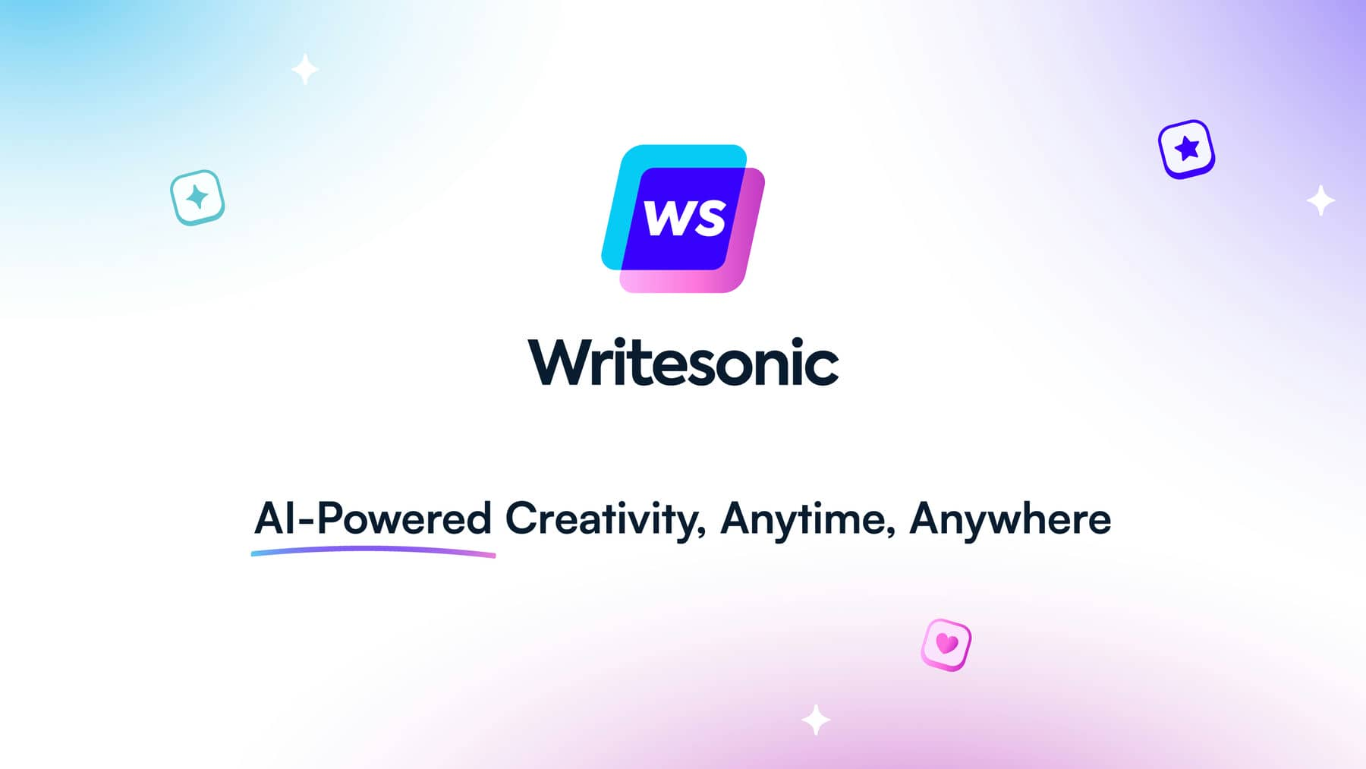

WritesonicAI is a modern device designed to simplify the design process and produce high quality writing quickly. This flexible machine intelligence penning assistant can be personalized to meet a wide range of penning needs, making it an invaluable asset to content creators, sellers, and companies.

## **Key Features**

* **Content Generation**: Creates well-written content based on user prompts. Whether you need an article, blog post, or marketing copy, WritesonicAI can deliver high-quality text efficiently.
* **Editing Tools**: Offers suggestions for improving grammar, style, and clarity, helping to refine and polish your writing.
* **SEO Optimization**: Enhances content for better search engine performance by suggesting keywords and optimizing structure, which is valuable for digital marketing and online content.

### **Best For**

WritesonicAI is ideal for users looking to generate and optimize content quickly, especially those involved in digital marketing and content creation.

### 

# **4. CopyAI**



CopyAI is a concentrated device designed to excel at branding and clever authoring, making it a crucial asset for pleased Godhead, sellers, and industry owners who need legal and capable text. The present AI-driven platform extends a set of tools designed to collect a multifaceted demand for state-of-the-art satisfied growth.

## **Key Features**

* **Content Creation**: Generates marketing copy, blog posts, and other types of creative writing based on user input, making it a versatile tool for content creators.
* **Idea Generation**: Assists in brainstorming new content ideas, helping to overcome creative blocks and develop fresh concepts.
* **Language Enhancement**: Improves the style and tone of the content, ensuring it is engaging and well-written.

### **Best For**

CopyAI is best suited for marketers and content creators needing creative and engaging copy for promotional purposes.

### 

# **5. JasperAI**



JasperAI is a highly flexible authoring assistant designed to meet a wide range of authoring needs, making it an indispensable tool for a wide range of users. JasperAI provides powerful tools for improving your writing skills, whether you are looking to create interesting content for web pages, trade details articles, or polish your existing text.

## **Key Features**

* **Content Generation**: Produces well-written content based on various prompts, suitable for articles, blog posts, and more.
* **Rewriting**: Offers options for rewriting text to improve or alter content while retaining its core message.
* **Grammar and Style Check**: Ensures that text is grammatically correct and stylistically polished, enhancing overall readability.

### **Best For**

JasperAI is ideal for users seeking a reliable tool for general writing and content improvement, offering flexibility and quality across different types of text.

### **Final Verdict**

The unique feature of such tools is that they can significantly increase harvesting and productivity. Whether you need a complete set of instruments admire PerfectEssayWriter.ai or specific content coevals with CopyAI and JasperAI, this AI assistant can create a composition system drum sander and be more efficient. You can improve your writing skills, produce higher quality content, and save precious moments by using the above innovations.