#### **CollegeEssay.org: User Review & Feedback of Their Essay Writer**

At times, I needed to write papers quickly, but I was unable to find any good AI essay writers. There are plenty in the market, but I could not find any generated content that was of good quality and also looked natural and original.

A few months back, I came across CollegeEssay.org and their AI essay writer. I experimented with it for a few weeks and I was amazed by the results. It generates clear and quality papers of all academic levels. The tool always met my requirements and specifications, allowing me to believe that CollegeEssay.org has integrated a very powerful AI.

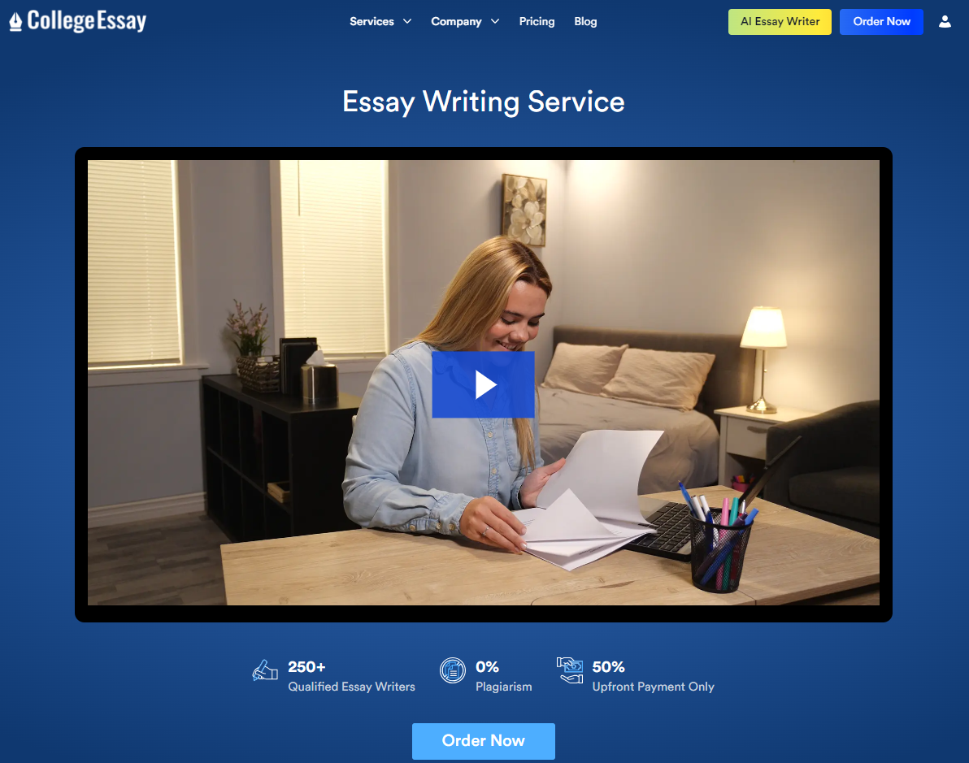

**What is CollegeEssay.org?**

CollegeEssay.org is a comprehensive [essay writing service](https://collegeessay.org/) designed to support students with a wide array of writing needs. From general essays and application essays to specialized papers and research reports, the platform offers a range of services including:

* **Custom Essays:** General, descriptive, narrative, persuasive, and argumentative essays.
* **Application Essays:** College admission, scholarship, and personal statements.
* **Research Papers:** Extensive research and term papers.
* **Specialized Essays:** Includes critical, exploratory, and process essays, among others.
* **Homework Help:** Assistance with various assignments and projects.
* **Other Services:** Capstone projects, lab reports, and PowerPoint presentations.

**CollegeEssay.org AI Essay Writer**

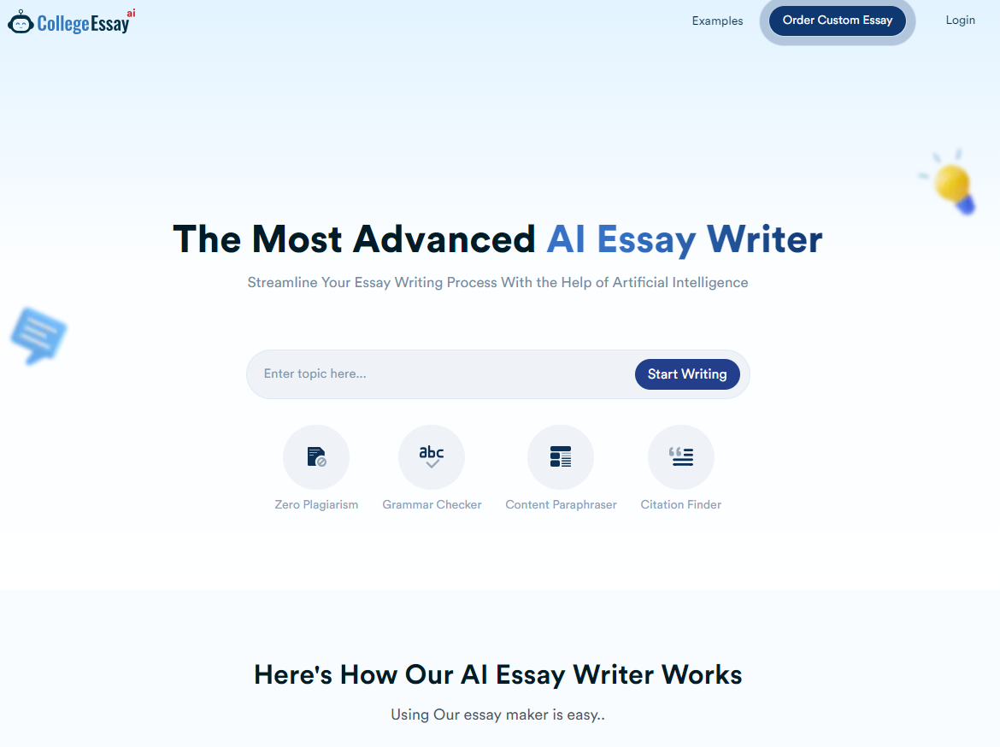

The CollegeEssay.org [Essay Writer](https://collegeessay.org/ai-essaywriter) is a powerful tool designed to streamline the essay writing process. Here’s a detailed look at how the interface works:

1. **Choose the Topic:** Start by entering the topic or title of your essay.
2. **Select Essay Length:** Specify the number of pages required for your essay.
3. **Set Academic Level:** Choose the academic level, from high school to postgraduate.
4. **Number of Sources:** Indicate how many sources or references should be included.
5. **Special Instructions:** Provide any additional instructions or specific requirements.
6. **Generate Essay:** Click on the “Generate” button to create your essay.

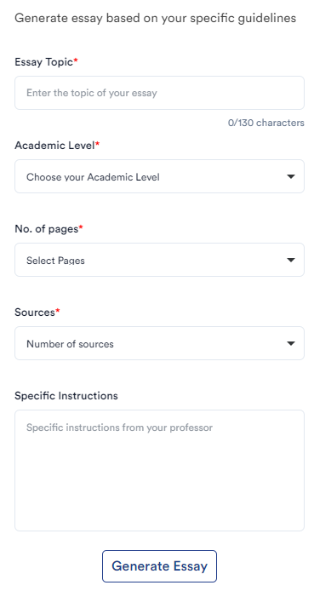

**A Snapshot on how the Essay Writer generates the paper:**

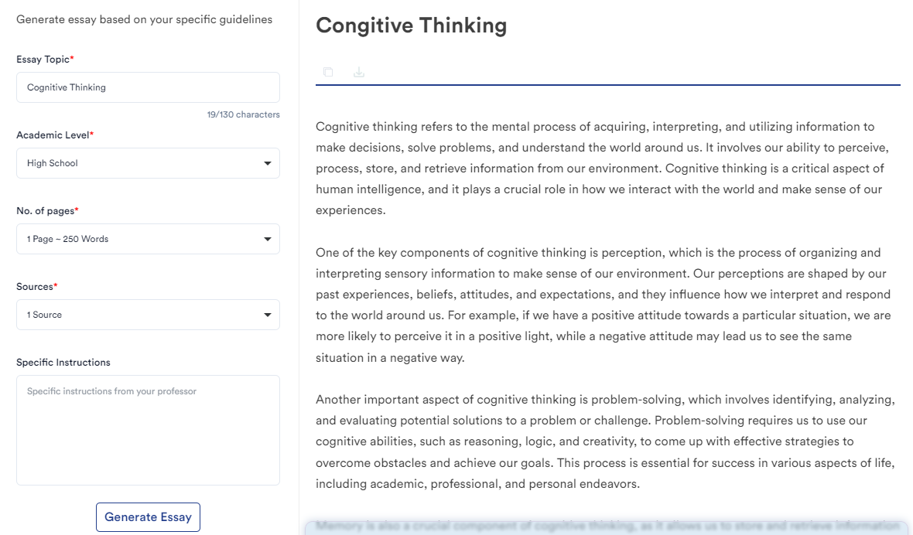

**User Testimonials**

Here’s what users are saying about CollegeEssay.org AI Essay Writer on their [review page](https://collegeessay.org/reviews):

* **Liam:** "This essay writer tool revolutionized my writing process. It provided insightful research and crafted engaging content effortlessly."
* **Ethan:** "I was amazed by CollegeEssay AI's ability to generate essays. It saved me hours of brainstorming and improved my grades."
* **Sophia:** "The tool's expertise is unparalleled. It helped me tackle complex topics and present my arguments with clarity."
* **Benjamin:** "Using it was like having a personal writing assistant. It offered valuable suggestions and refined my writing style."
* **Ava:** "Thanks to CollegeEssayAI, I met my tight deadline without compromising quality. It's a game-changer for students."

Some other AI essay writer reviews on independent review websites like [SiteJabber](https://www.sitejabber.com/reviews/collegeessay.org) and [Reviews.io](https://www.reviews.io/company-reviews/store/www.collegeessay.org?mohLu91):

* [**James T**](https://www.sitejabber.com/reviews/collegeessay.org#5191) ⭐️⭐️⭐️⭐️⭐️   
  "This user-friendly tool by CollegeEssay.org simplifies the essay-writing process, offering a seamless experience from start to finish. What sets CollegeEssay.org AI Essay Writer apart is its intuitive interface, which allows students to effortlessly navigate through the essay generation process."
* [**Robert Hawk**](https://reviews.io/company-review/store/www.collegeessay.org/22249598) ⭐️⭐️⭐️⭐️⭐️  
  "I recently used the AI essay writer tool from CollegeEssay.org, and I am very impressed. The tool automatically generated my essay in no time, and the quality was surprisingly good. It followed the guidelines I provided and produced a well-structured, coherent essay. Its AI tool saved me a lot of time and effort."

**Authenticity, Credibility & Security Feedback of CollegeEssay.org**

CollegeEssay.org AI Essay Writer is a trusted tool for students. It has many various certifications which prove the safety and security of this service.

First, it's DMCA Protected, so one can be sure that the content delivered will be unique. Besides, it's PCI DSS compliant—the processing of your payment information will be secure.

It's SiteLock Protected and Secure Protected, meaning the safety of your private data is guaranteed. They also facilitate Authorize.Net payment processing with enhanced security.

All in all, CollegeEssay.org AI Essay Writer is something one can rely on with surety. The tool is easy to use and writes quality essays. Just remember to use the tool as a guide and not submit the generated content as your own work.

In my review of CollegeEssay.org’s AI Essay Writer, it’s clear that this tool is a valuable asset for students looking to enhance their essay writing process. With its intuitive interface and robust features, it provides efficient and high-quality content generation, making it a useful resource for both academic and professional writing.

**FAQs**

**Q. How does CollegeEssay.org's AI Essay Writer ensure originality of content?**

The AI Essay Writer checks for any duplication of the result against a massive database to ensure it is original and not plagiarized at all.

**Q. Does the AI Essay Writer allow for different writing styles or tones?**

Yes, Be it a formal academic tone or conversational style, it is able to churn out material that best suits the needs.

**Q. What to do if the essay that comes out of the generator does not turn out as per expectation?**

In case the generated essay does not meet your expectations, you can review and request a revision. Customization in the AI tool lets you adjust only input parameters and regenerate the essay until it suits your requirement.

**Q. How does AI Essay Writer handle complex or technical subjects?**

The AI essay writer is able to help in any topic, however complex or technical. Sophisticated algorithms are engaged in information retrieval and writing of essays with coherence. It is, therefore, useful in subjects that need in-depth research and analysis.

**Q. Am I allowed to use the AI Essay Writer for non-academic writing, such as personal statements or creative writing?**

This is a multi-purpose AI Essay Writer that you can use for all sorts of writing other than your academic essays, such as helping in personal statements and creative writing projects. The facility also extends to cover professional documents by customizing the content according to need.

**Q. How will CollegeEssay.org safeguard my personal information while using the AI Essay Writer?**

Security at CollegeEssay.org deploys safe encryption methods and is in compliance with PCI DSS. This will ensure that all your personal and payment information is kept confidential when engaging with the AI Essay Writer.