# **6 Must-Try AI Essay Writing Tools in 2024 | Get Started Today**

AI writing tools are revolutionizing the way students approach essay writing. With advancements in artificial intelligence, these tools can help you craft essays faster, ensure better grammar, and even improve your writing style. Whether you're working on a school assignment or preparing a research paper, [AI tools can guide you every step of the way](https://fizara.com/created-an-assignment-and-scored-an-a-using-these-ai-tools/).

In 2024, there are several AI essay writing tools available that offer unique features to make your writing experience easier and more efficient. From paraphrasing to content generation, these tools can handle a variety of tasks that will improve the quality of your essays. This list will introduce you to the [best AI essay writing tools of 2024](https://ventsmagazine.com/2024/11/04/free-ai-writing-tools-top-picks-for-2024/) that can help you get started today.

With a wide range of options to choose from, it can be tough to know which AI essay writing tool is best suited for your needs. In this article, we’ll break down six must-try AI essay writing tools to help you make an informed decision. Let’s dive into the details of these platforms, their key features, and what makes them stand out in 2024.

## **Best AI Essay Writer Tools**

**1**. PerfectEssayWriter.ai - Best AI Essay Writer Overall **✍️🚀**

**2. MyEssayWriter.ai -** Write Perfect Essays Every Time ✍️🎓

**3. EssayService.ai -** Get Your Essays Written Fast 📝💡

**4. Copy.ai -** Top AI Writing Assistant 📝✨

**5. Jasper.ai** Best AI Content Generator - 🧠📚

**6. Preplexity.ai -** Top Research & Writing Tool 🔍📖

### 

## **1. PerfectEssayWriter.ai**

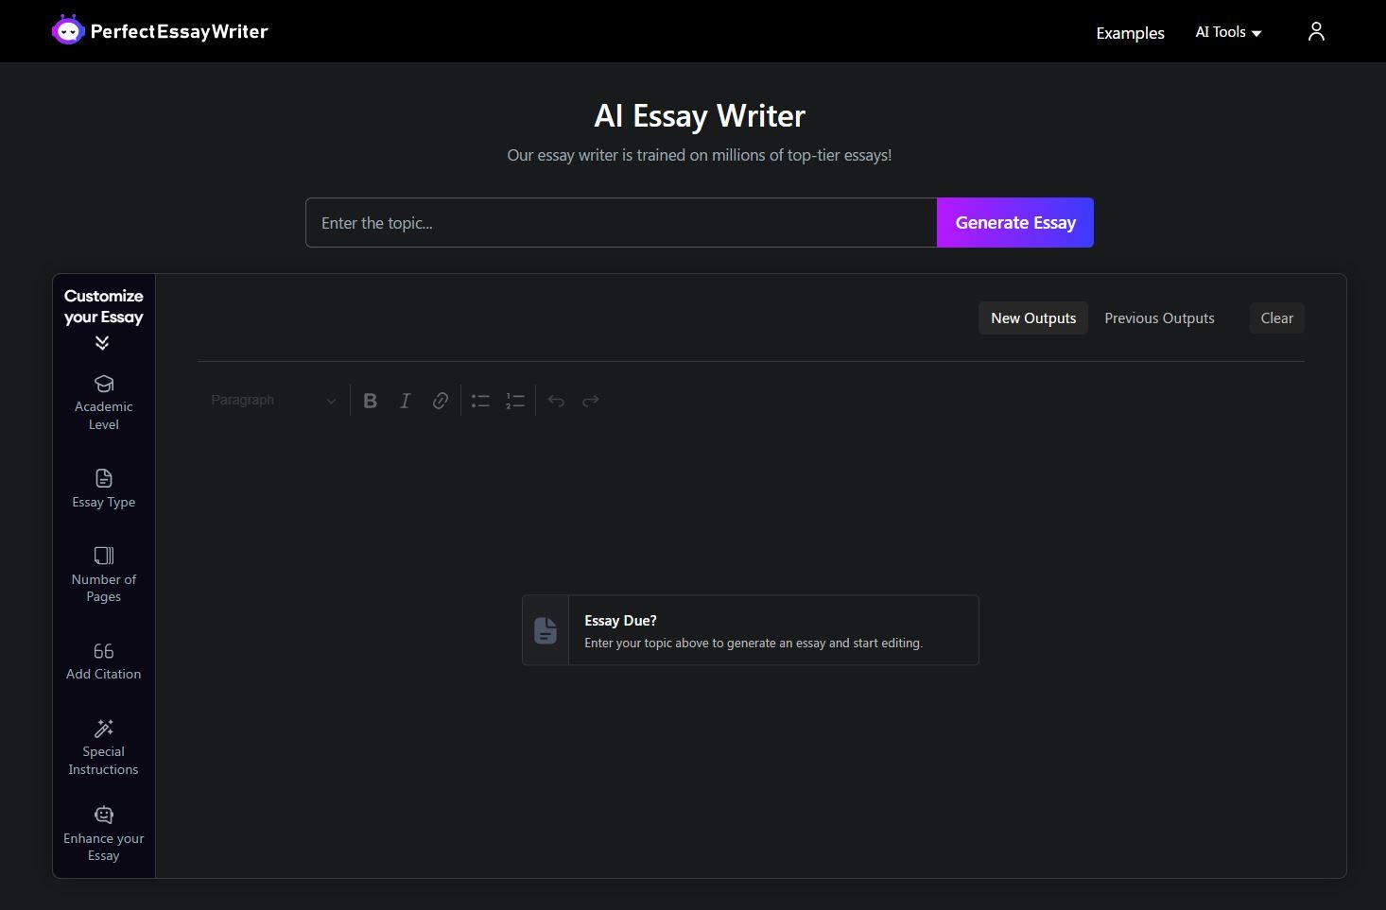

PerfectEssayWriter.ai is an AI essay writing tool designed to help students create well-structured essays with ease. It uses advanced algorithms to generate high-quality content, offering writing assistance in various formats.

Whether you're writing a narrative, argumentative, or descriptive essay, this tool helps ensure your work is clear, concise, and error-free. The tool analyzes your input to craft content that fits academic standards and provides detailed suggestions for improvements.

It is particularly useful for students who need assistance with brainstorming ideas and organizing their thoughts. Additionally, it offers features like grammar checking and plagiarism detection to ensure originality and academic integrity.

**Discover More at:** [Click Here](https://www.perfectessaywriter.ai/)

PerfectEssayWriter.ai offers a suite of tools, including a grammar checker, paraphrasing tool, and AI humanizer. Its grammar checker was robust, catching even the most subtle errors, while the paraphrasing tool helped in rephrasing sentences without losing their original meaning. [We Tested AI Productivity Tools—Here’s What Actually Helped](https://flaremagazine.co.uk/technology/we-tested-ai-productivity-tools-heres-what-actually-helped/#:~:text=PerfectEssayWriter.ai%20offers%20a%20suite%20of%20tools%2C%20including%20a%20grammar%20checker%2C%20paraphrasing%20tool%2C%20and%20AI%20humanizer.%20Its%20grammar%20checker%20was%20robust%2C%20catching%20even%20the%20most%20subtle%20errors%2C%20while%20the%20paraphrasing%20tool%20helped%20in%20rephrasing%20sentences%20without%20losing%20their%20original%20meaning.) **By Flaremagazine.co.uk**

### **Key Features**

* Offers templates that fit a wide variety of essay types and formats.
* Provides instant feedback on your writing to improve clarity and structure.
* Scans your essay for any instances of plagiarism to ensure originality.
* Reviews your essay for grammatical mistakes and stylistic improvements.
* It suggests relevant and engaging topics based on your subject area.

**Why Choose PerfectEssayWriter.ai?**

PerfectEssayWriter.ai is perfect for students who need quick, quality writing assistance. Its AI-driven algorithms help generate essays that meet academic standards. Whether you’re stuck on a topic or need help refining your content, it’s the tool that can boost your writing process. Plus, it helps with grammar and plagiarism detection to ensure your essays are polished. It’s a reliable companion for students at all levels.

**Online Reputation**

PerfectEssayWriter.ai has earned a good reputation among students for its ease of use and quick turnaround. Many users appreciate its user-friendly interface, which makes it accessible even to beginners. The tool has received positive feedback for delivering high-quality essays that are clear and free from errors. Users also commend its plagiarism detection features, which ensure originality in essays. Overall, it is considered a trustworthy AI tool in the academic community.

Also Checkout: [5 Top AI Writing Tools for Students: Tested and Reviewed](https://www.tribuneindia.com/news/impact-feature/5-top-ai-writing-tools-for-students-tested-and-reviewed-635768)

## **2. MyEssayWriter.ai ✍️🎓**

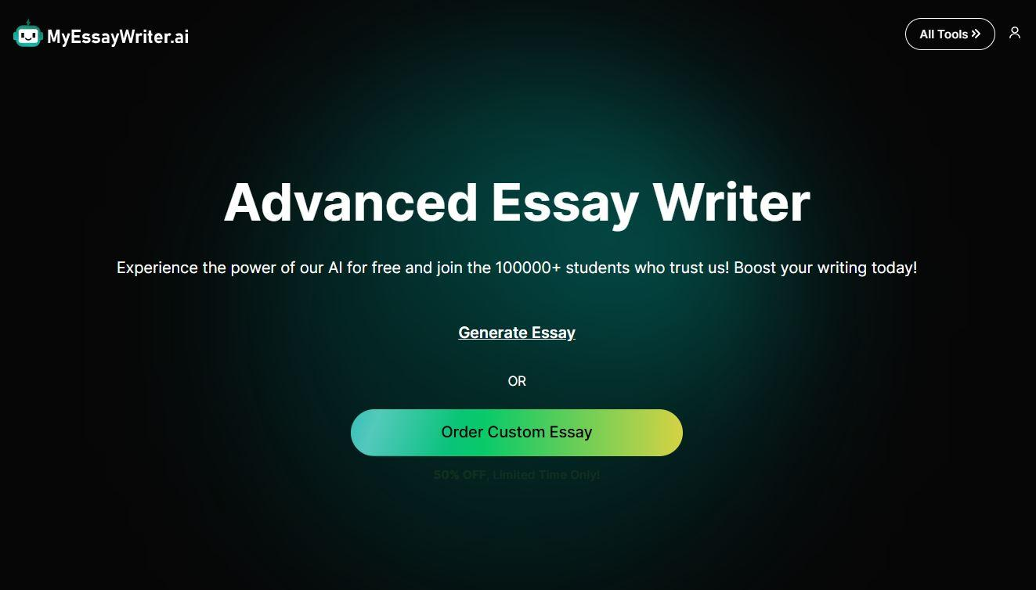

MyEssayWriter.ai is an AI-powered tool that helps you write essays quickly and efficiently. Whether you're a high school student or in college, this tool simplifies the essay-writing process by generating ideas, drafting content, and checking for errors. It’s designed to help you save time while ensuring the quality of your work. The platform provides topic suggestions and outlines, making it easier to start your essay without getting stuck. MyEssayWriter.ai also helps with proper citation and reference formatting to ensure academic accuracy. Its quick generation process and easy-to-navigate interface make it an excellent choice for students who need help on short notice.

### **Key Features**

* Quickly generates essays on any topic, saving time during tight deadlines.
* Helps with proper citation formatting, including [MLA format](https://www.perfectessaywriter.ai/citation/citation-styles/mla), APA, and [Chicago style](https://www.perfectessaywriter.ai/citation/citation-styles/chicago-style).
* Provides helpful prompts to guide your writing process from start to finish.
* Identifies errors and suggests corrections for grammar and punctuation.
* Customizes generated essays based on user-specific input and preferences.

### **Why Choose MyEssayWriter.ai?**

MyEssayWriter.ai is ideal for students who want to streamline their essay-writing process. It not only helps generate ideas but also drafts complete essays based on the input provided. With its customizable features, you can ensure your essay matches your style. The built-in citation generator makes it easy to reference sources correctly. It’s a great option for students who want to improve both the quality and speed of their writing.

### **Online Reputation**

MyEssayWriter.ai is praised for its ease of use and the helpfulness of its features. Many students appreciate its ability to generate detailed outlines and suggestions for topics. It has earned positive reviews for its accuracy in grammar checks and plagiarism prevention. Users also value the tool’s quick and reliable essay generation process. With its strong reputation for quality and efficiency, it’s trusted by students around the world.

## **3. EssayService.ai**

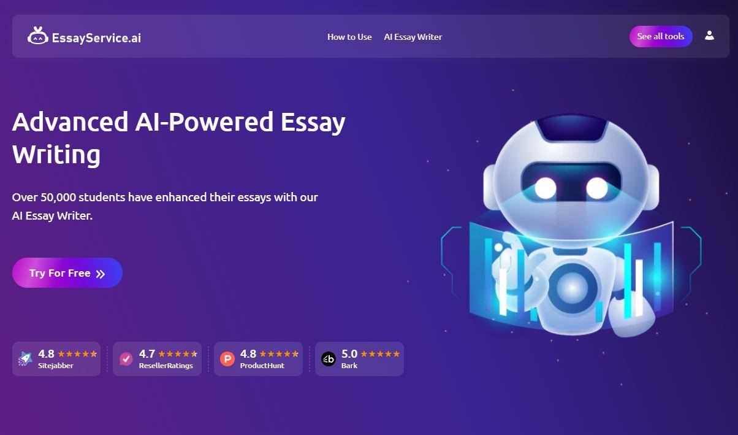

EssayService.ai is an AI writing assistant designed to simplify the process of writing essays. It helps students by providing structured essay outlines, helping with topic selection, and generating content that fits academic standards. Whether you’re writing a persuasive, informative, or narrative essay, this tool can assist with every step of the writing process. EssayService.ai offers real-time feedback and suggestions to help you improve your writing. It provides a range of templates for different types of essays, ensuring your content is well organized and adheres to academic guidelines. Additionally, it offers grammar checks and plagiarism detection, making it a comprehensive tool for students at any level.

### **Key Features**

* Offers well-organized outlines to get your essay started with a solid structure.
* Provides ongoing help with refining content as you write.
* Supports different essay types like argumentative, descriptive, and persuasive.
* Suggests specific topics related to your subject or course.
* Ensures your essay is unique by scanning it for plagiarism across the web.

### **Why Choose EssayService.ai?**

EssayService.ai is a great tool for students who need help from start to finish. It can assist with brainstorming ideas, structuring essays, and generating high-quality content. The tool also helps refine your essay by checking for grammar mistakes and plagiarism. If you want a tool that gives real-time feedback and allows you to improve your work continuously, this is a solid choice. It’s reliable and efficient, making it an excellent resource for students under tight deadlines.

### **Online Reputation**

EssayService.ai has built a positive reputation for providing quality, well-structured essays quickly. Many users enjoy how the platform helps them with both writing and research. The tool has received favorable reviews for being user-friendly and providing real-time suggestions to improve essay quality. Students particularly appreciate its plagiarism detection features. Overall, it is trusted by students who need fast, high-quality writing assistance.

## **4. Copy.ai ✏️✨**

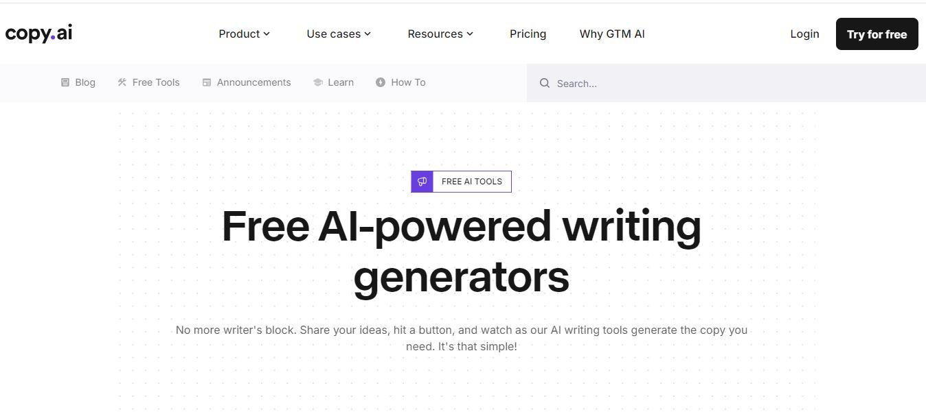

Copy.ai is an AI tool that specializes in generating high-quality content. While it’s popular for marketing and copywriting, it also offers great features for essay writing. With its AI-powered templates, it can assist in drafting essays, articles, and other forms of written content in just a few clicks.

### **Key Features**

Content creation templates

AI-based content generation

Multi-language support

Plagiarism-free content

Time-saving automation tools

### **Why Choose Copy.ai?**

Copy.ai is perfect for students looking to create quick and engaging content. It’s fast, simple, and effective in generating essays based on provided topics. The platform also offers templates to help organize content, which is ideal for those who struggle with structure. It’s a great choice if you want to improve your writing and save time. The tool ensures plagiarism-free essays that are unique and ready for submission.

**Online Reputation**

Copy.ai is widely recognized for its efficiency in content creation. Many users have shared positive experiences about how it saves time and helps produce high-quality content. The tool has a solid reputation in the writing community, thanks to its accuracy and ease of use. Students particularly like the fact that it ensures plagiarism-free content. Copy.ai is often recommended for those looking to enhance their writing with the help of AI.

## **5. Jasper.ai 📝⚡**

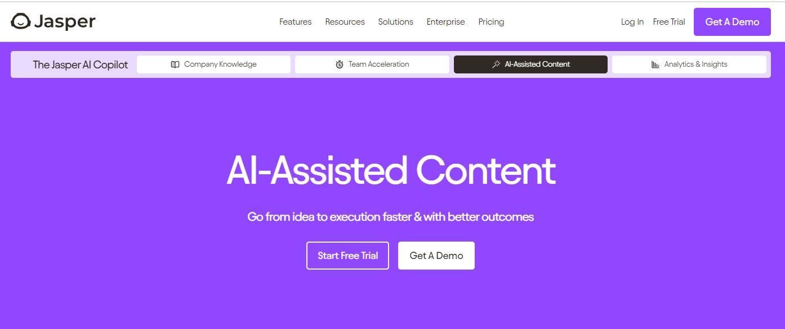

Jasper.ai is an AI-powered assistant designed for various writing needs, including essays, blog posts, and more. Its advanced AI technology helps you generate ideas, improve your writing, and make your essays stand out. Jasper is perfect for students who want to enhance their writing skills and creativity.

### **Key Features**

AI-powered content generation

Grammar and spelling checker

Multiple writing tones and styles

Plagiarism detection tools

Customizable templates for different essay types

**Why Choose Jasper.ai?**

Jasper.ai is ideal for students who want to improve their writing quality. It helps generate unique content and suggests improvements to enhance readability. The tool’s customizable templates ensure your essays match your desired writing style. It also offers plagiarism checks, so your essays remain original. Whether you’re writing for school or other purposes, Jasper is a great AI writing companion.

**Online Reputation**

Jasper.ai is highly rated for its ease of use and the quality of content it generates. Many students and writers have shared their positive experiences using the tool for both academic and professional purposes. The platform is often praised for its grammar checks and plagiarism detection features. Users appreciate the variety of writing styles it offers. Jasper is considered a reliable and versatile AI writing assistant.

## **6. Preplexity.ai ✍️📚**



Preplexity.ai is an AI writing tool that focuses on helping users with research and essay writing. It’s designed to assist students in gathering information, structuring essays, and generating quality content quickly. This tool simplifies the writing process by providing relevant research material and drafting essays based on the gathered information.

### **Key Features**

Research material gathering

AI essay generation

Topic suggestion assistance

Grammar and plagiarism checker

User-friendly interface

### **Why Choose Preplexity.a?**

Preplexity.ai is a great tool for students looking for research assistance. It simplifies the process by providing useful material and automatically generating essays based on that. With its AI-powered features, it ensures your essays are well-structured and error-free. It also includes grammar and plagiarism checks for high-quality results. If you’re looking to streamline both the research and writing process, Preplexity is a solid choice.

### **Online Reputation**

Preplexity.ai has received positive reviews for its research and writing capabilities. Users enjoy how it assists with gathering relevant material for essays. The tool is often praised for its accuracy and ability to generate essays based on the provided data. Many students find it helpful for streamlining the entire essay-writing process. Preplexity.ai is considered an efficient tool by those who want to focus on research and writing simultaneously.

### **Final Call**

With the integration of [artificial intelligence in education](https://www.perfectessaywriter.ai/blog/artificial-intelligence-in-education), students are witnessing a transformative shift in how they approach learning and manage academic tasks. AI tools are reshaping traditional educational methods by offering tailored support, boosting efficiency, and providing innovative solutions to everyday challenges.

These tools not only save valuable time for students by handling repetitive tasks like proofreading and formatting, but they also allow students to focus more on critical thinking and creative aspects of their assignments.

The [future of AI in education](https://www.perfectessaywriter.ai/blog/future-of-ai-in-education) holds even greater promise as technology continues to evolve. AI is anticipated to grow more personalized and adaptive, aligning more closely with individual learning styles and needs. This means that future AI systems could provide unique recommendations, resources, and feedback for each student, making learning more accessible and effective across different educational levels.

AI-powered platforms will likely expand their capabilities to encompass real-time progress tracking, proactive study suggestions, and deeper insights into subject mastery.

Understanding [how to train AI with real-world use cases](https://www.perfectessaywriter.ai/blog/how-to-use-ai-to-generate-sentences-for-business) is essential for developing tools that truly benefit students. By using relevant data from real educational scenarios—such as common essay topics, frequently asked questions, and student feedback—AI models can better understand the challenges students face.

Training AI with these use cases enables it to offer practical solutions and advice that reflect real needs in the classroom. This approach creates a continuous improvement loop, where AI tools learn from real student interactions to become even more useful over time.

In short, AI’s potential in education is vast, and as these tools evolve, they will become more intuitive, impactful, and accessible, ultimately fostering a future where education is more engaging and student-centered. By embracing AI now, students and educators alike can gain skills, insights, and support that enhance the overall learning experience.

### **FAQs**

**What are AI essay writing tools?**

AI essay writing tools are software programs that utilize artificial intelligence to assist students in writing essays. These tools can generate content based on input prompts, check for grammar and spelling errors, and ensure that the work is original by detecting plagiarism. They help students streamline the writing process and produce high-quality essays more efficiently. These tools are particularly useful for students who are struggling with writer's block or tight deadlines.

**How do AI essay writing tools work?**

AI essay writing tools work by analyzing the input you provide, such as a topic or prompt, and then generating content based on that input. These tools use advanced machine learning models to understand the context of the topic and craft a well-structured essay. They can also suggest improvements for style, grammar, and clarity. Additionally, some AI tools offer real-time feedback to help students refine their work. The AI continuously learns from user input, improving the suggestions it provides over time.

**Are AI essay writing tools accurate?**

Yes, most AI essay writing tools are highly accurate and designed to ensure that the content is grammatically correct, well-structured, and original. These tools use advanced algorithms to analyze the content and offer improvements based on linguistic rules, structure, and style. Many tools also include plagiarism detection features to help ensure the work is unique and meets academic standards. While not perfect, AI essay writing tools are highly effective and can significantly improve your writing accuracy and efficiency.

**Can AI tools help with research for essays?**

Yes, several AI tools, such as Preplexity.ai, can assist with gathering research material for essays. These tools quickly pull relevant data and academic sources based on the keywords or topics you input, simplifying the research process. This allows students to focus on writing rather than spending excessive time searching for sources. AI research tools can also organize and summarize research findings, helping students develop a clearer understanding of their topics. By providing relevant, up-to-date information, AI research tools enhance the quality and depth of your essays.

**Are AI essay writing tools safe to use?**

Yes, AI essay writing tools are safe to use. Most platforms take privacy and security seriously, ensuring that personal data is not stored or misused. These tools do not plagiarize content and are designed to generate original material based on user input. Many AI tools include built-in plagiarism detectors to check for any accidental similarities with other works. These features ensure that the content generated is unique, helping students avoid the risks of submitting plagiarized work. Additionally, reputable platforms follow data protection regulations to safeguard users' privacy.